ADC Lab Logbook
Part 1 | Section 2: Reactive Components
Section 2: Reactive Components
Before the Lab: Theoretical Preparation
Unlike resistors, capacitors and inductors exhibit frequency-dependent impedance. From the lecture, the impedance of an ideal capacitor is Zᶜ = 1/(jωC), and that of an ideal inductor is Zᴸ = jωL, where ω = 2πf.
To verify this behavior, a series RL circuit (R = 10 Ω, L = 1 mH) was first analyzed theoretically. The total impedance is given by Z = jωL + R. The magnitude |Z| and argument arg(Z) were calculated at logarithmically spaced frequencies from 1 Hz to 100 kHz using a spreadsheet:

Frequency (Hz) | |Z| (Ω) | arg(Z) (rad)
1 | 10.0 | 0
3.2 | 10.00002 | 2.01×10⁻³
10 | 10.0001 | 6.28×10⁻³
32 | 10.002 | 0.0201
100 | 10.01 | 0.0627
320 | 10.2 | 0.198
1000 | 11.8 | 0.561
3200 | 22.5 | 1.109
10000 | 63.6 | 1.143
32000 | 201.3 | 1.521
100000 | 628.4 | 1.555

The results were plotted as |Z| vs frequency (log-log scale) and arg(Z) vs frequency. At low frequencies, the inductive reactance is negligible and |Z| ≈ R = 10 Ω. At high frequencies, the inductive impedance dominates, causing |Z| to increase linearly with frequency on the log-log plot. The argument approaches π/2 rad as the inductor becomes the dominant component.

Measurement Method
The impedance measurement technique from Section 1 was applied throughout, using the potential divider relationship Z = R·(Vᴻ/Vᵆ). The series resistor R was adjusted at each frequency to keep the amplitudes of Vᴻ and Vᵆ comparable, minimizing measurement error. Two specific cases were identified:
• When Vᴻ is too small (component impedance ≫ R), R should be decreased to improve signal-to-noise ratio.
• When the MATH channel appears blocky or clipped (component impedance ≪ R), R should be increased to reduce loading effects.

Characterizing a Capacitor
1 μF Capacitor
The impedance of a 1 μF capacitor was measured over the frequency range 1 Hz to 32 kHz. Since capacitive impedance is very large at low frequencies, a starting resistor of R = 100 kΩ was used, adjusted downward as frequency increased.

Frequency (Hz) | R (Ω) | Vz (mV) | Vr (mV) | |Z| (Ω)
1 | 100k | 206 | 144 | 144k
3.2 | 100k | 105 | 230 | 45.7k
10 | 100k | 37.5 | 249 | 15k
32 | 1k | 244 | 57 | 4.3k
100 | 1k | 204 | 133 | 1.5k
320 | 1k | 106 | 208 | 510
1000 | 1k | 40 | 226 | 177
3200 | 100 | 84 | 147 | 57
10000 | 100 | 29.6 | 163 | 18.2
32000 | 100 | 10 | 154 | 6.5

All results are based on experimentally measured data, not numerical or circuit simulations.
The data were plotted as log|Z| vs logƒ. A linear fit yielded the relationship log(Z) = −0.965·log(ƒ) + 5.132 (R² = 0.9997). The theoretical gradient for an ideal capacitor is −1, and the measured value of −0.965 is in close agreement, confirming the expected capacitive behavior. Logarithmic scaling was employed to clearly resolve the wide dynamic range of impedance values across the frequency sweep.
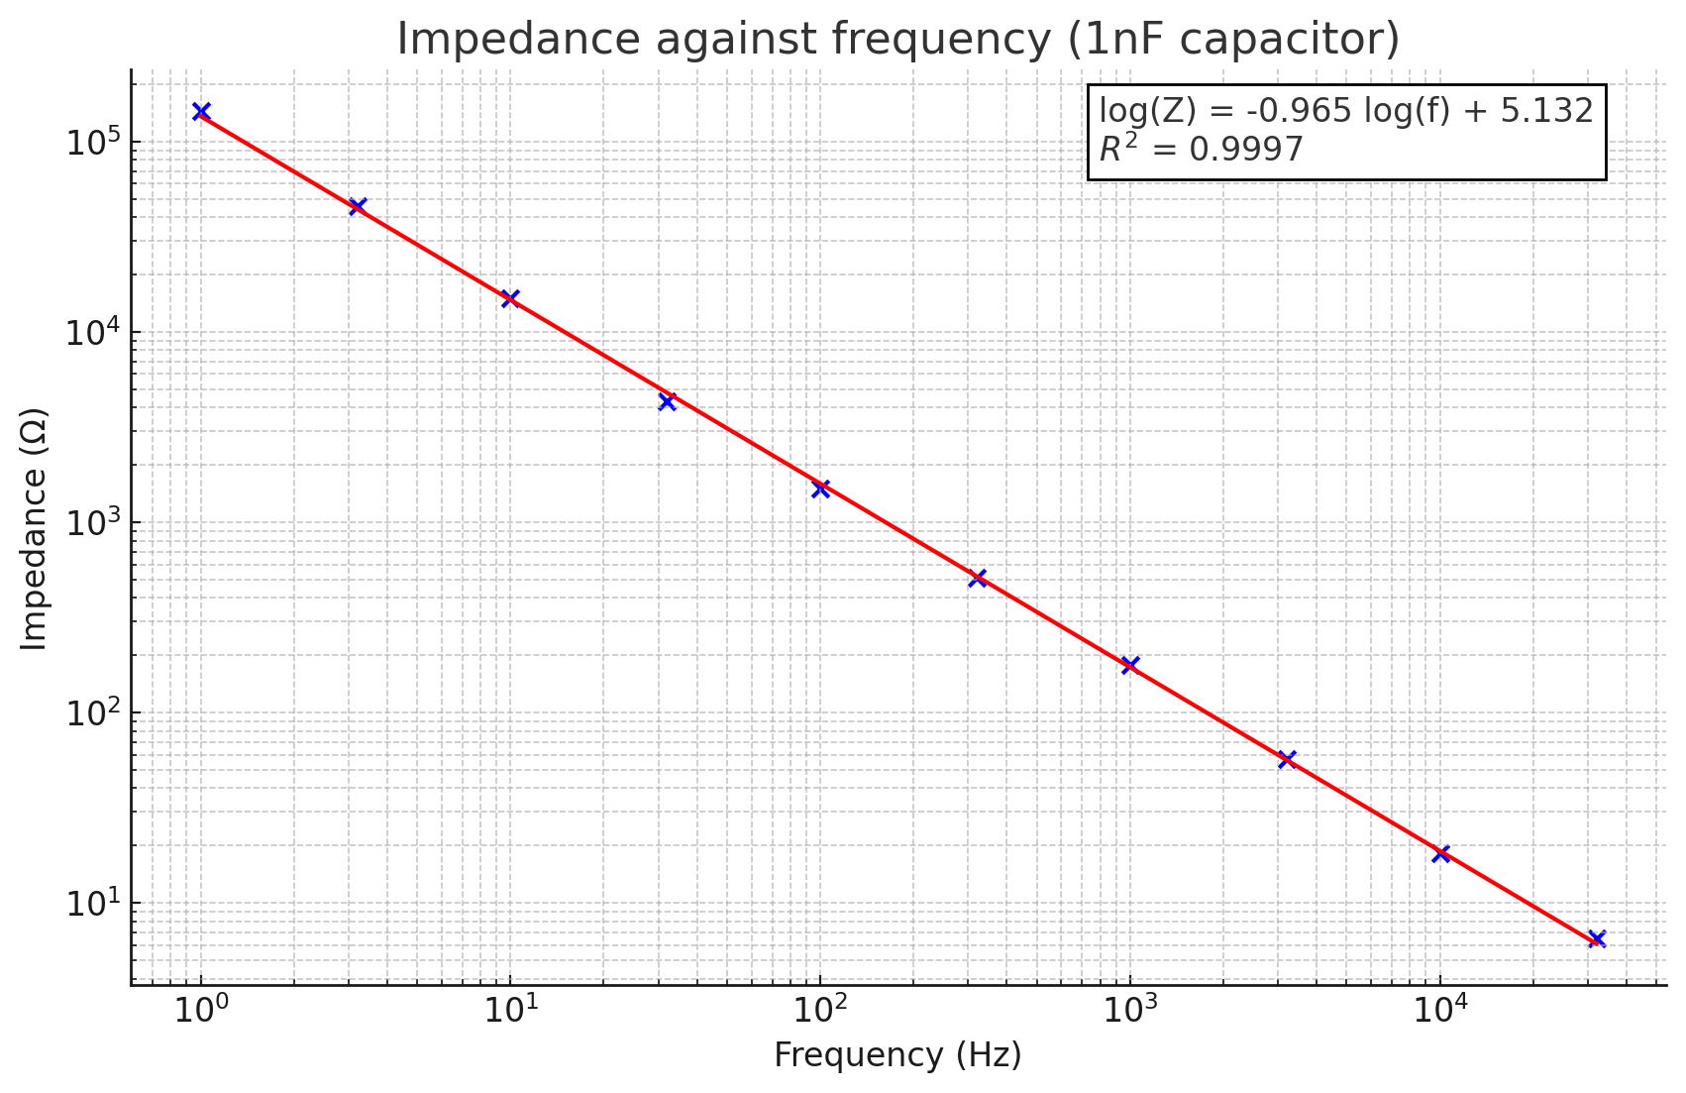

33 nF Capacitor
A second capacitor of 33 nF was characterized over the same frequency range. A 1 MΩ starting resistor was used at low frequencies due to the much higher impedance of this smaller capacitance.

Frequency (Hz) | R (Ω) | Vz (mV) | Vr (mV) | |Z| (Ω)
1 | 1M | 224 | 56.6 | 3958k
3.2 | 1M | 194 | 133.1 | 1458k
10 | 100k | 242 | 56 | 432k
32 | 100k | 206 | 139 | 149k
100 | 100k | 110 | 226 | 48.7k
320 | 1k | 248 | 20.3 | 12.2k
1000 | 1k | 246 | 51.9 | 4.74k
3200 | 1k | 233 | 200 | 1.17k
10000 | 10 | 248 | 12 | 206.7
32000 | 1 | 248 | 7.9 | 28.9

All results are based on experimentally measured data, not numerical or circuit simulations.
The log-log linear fit gave log(Z) = −1.104·log(ƒ) + 6.773 (R² = 0.9902), again close to the theoretical gradient of −1.
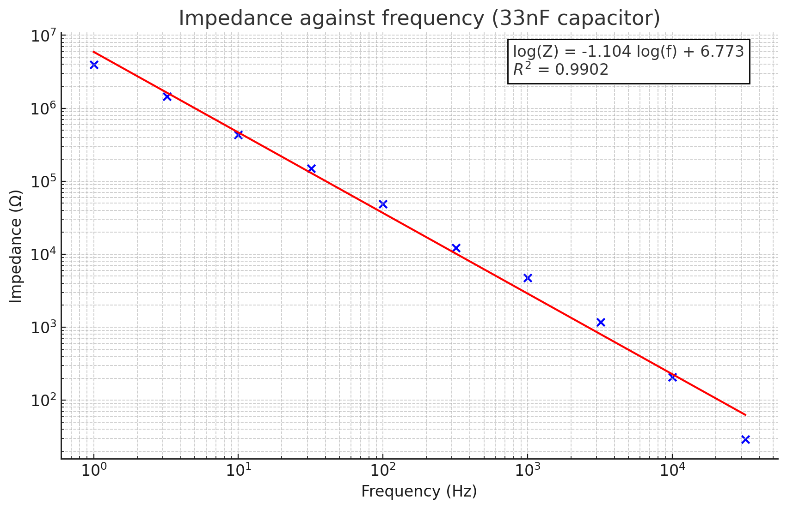

Characterizing an Inductor
1 mH Inductor
The 1 μF capacitor was replaced by a 1 mH inductor. Since inductive impedance is proportional to frequency, it is very small at low frequencies. Accordingly, a starting resistor of R = 1 Ω was used and increased progressively with frequency.

Frequency (Hz) | R (Ω) | Vz (mV) | Vr (mV) | |Z| (Ω)
1 | 1 | 37.2 | 6.8 | 5.47
3.2 | 1 | 38 | 6.2 | 5.13
10 | 1 | 38 | 6.6 | 5.76
100 | 1 | 37.2 | 6 | 6.2
1000 | 10 | 38.4 | 39 | 9.85
3200 | 10 | 73 | 34 | 21.47
10000 | 100 | 88 | 144 | 61.1
32000 | 1k | 44.8 | 219.2 | 204.38

All results are based on experimentally measured data, not numerical or circuit simulations.
The measured data were plotted alongside a theoretical line derived from Z = jωL. At low frequencies, the measured impedance plateaus rather than continuing to decrease, revealing the presence of the inductor's parasitic (series) resistance. The theoretical line assumes an ideal inductor and thus continues to decrease, whereas the measurement converges to a horizontal asymptote equal to the parasitic resistance.
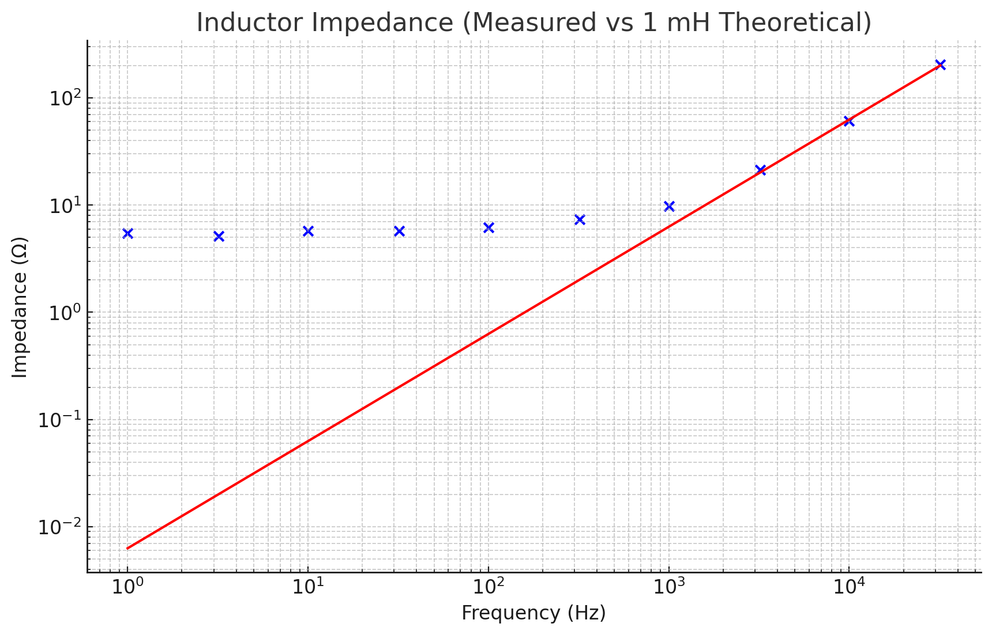

100 mH Inductor
A 100 mH inductor was also characterized using the same method over the range 1 Hz to 32 kHz.

Frequency (Hz) | R (Ω) | Vz (mV) | Vr (mV) | |Z| (Ω)
1 | 1 | 200 | 85.6 | 2.3
3.2 | 1 | 208 | 79.3 | 2.6
10 | 1 | 204 | 41.1 | 5
32 | 10 | 350 | 70 | 50
100 | 10 | 392 | 28.5 | 138
320 | 100 | 352 | 120 | 293
1000 | 100 | 452 | 73.2 | 618
3200 | 1k | 416 | 215 | 1935
10000 | 10k | 264 | 425 | 6212
32000 | 10k | 450 | 216 | 20833

All results are based on experimentally measured data, not numerical or circuit simulations.
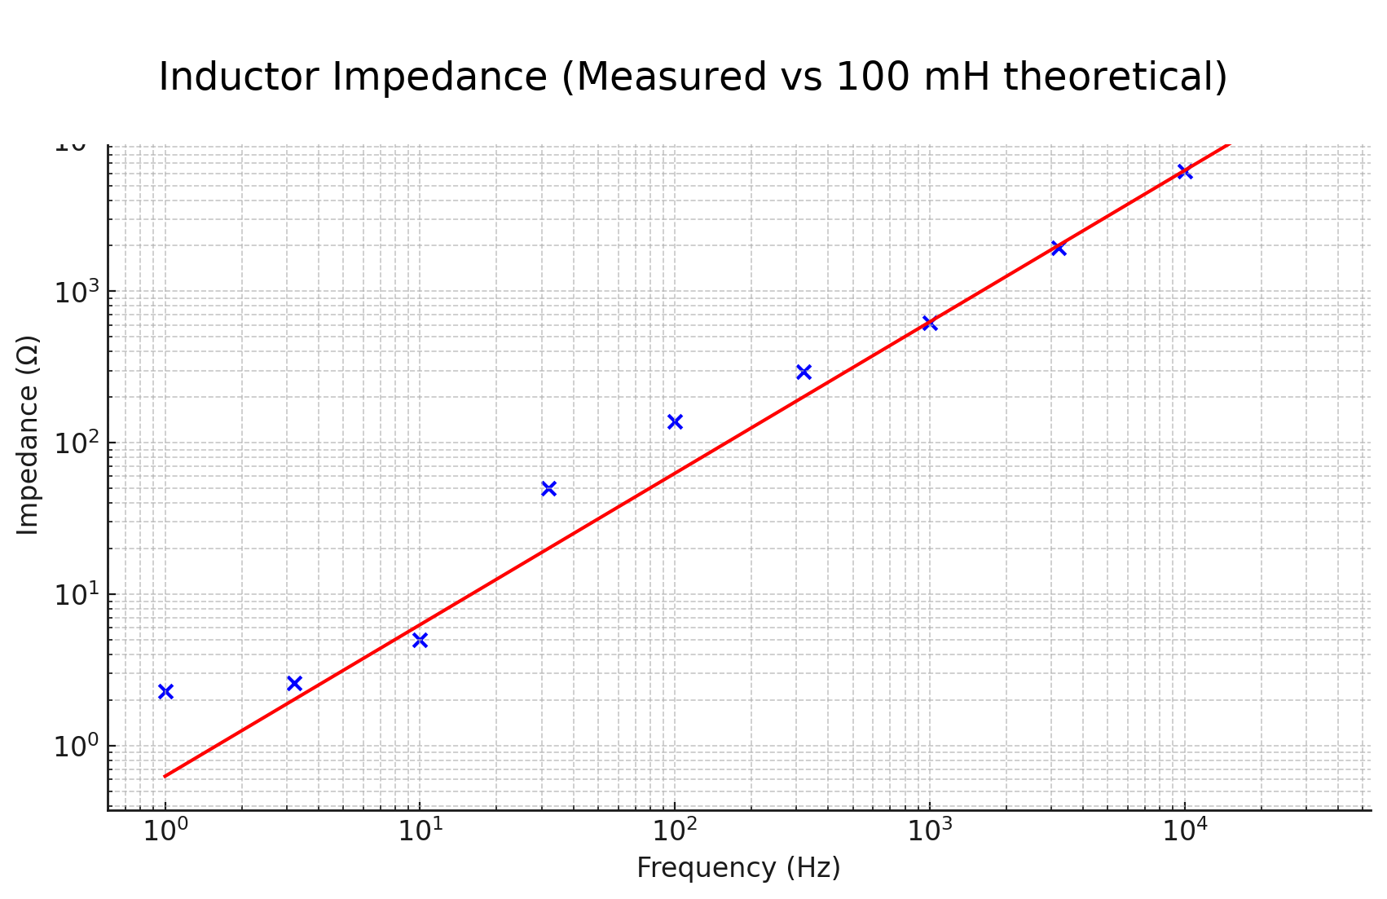

Discussion: Sources of Measurement Discrepancy
Two principal sources of deviation between measured and theoretical impedance values were identified:

1. Component tolerances. Real passive components are manufactured with finite precision. For example, a nominal 100 Ω resistor may have an actual value in the range 95–105 Ω. This was directly observed in Section 1, where the nominally 10 kΩ resistor measured 9.74 kΩ, representing a 2.6% deviation.

2. Parasitic resistance. Neither capacitors nor inductors are ideal reactive elements in practice. A more accurate model includes a parasitic series resistance Rₚ, such that:
Zᶜ = 1/(jωC) + Rₚ Zᴸ = jωL + Rₚ
For a capacitor, as frequency increases, 1/(jωC) tends to zero, and the impedance approaches Rₚ rather than zero. For an inductor, as frequency decreases toward zero, the impedance approaches Rₚ rather than zero — consistent with the horizontal asymptote observed in the 1 mH inductor plot.

Challenge: Determining Unknown Component Values
The impedance method was applied to determine the capacitance and inductance of two unknown capacitors and two unknown inductors. Measurements were taken at five frequencies between 1 kHz and 10 kHz, and the component values were extracted using:
C = 1/(2πf·|Z|) L = |Z|/(2πf)
The calculated values were subsequently verified using an RLC bridge for direct measurement.

Capacitors
Freq (Hz) | Cap 1: R (Ω) | Vz | Vr | |Z| (Ω) | C (nF) | Cap 2: R (Ω) | Vz | Vr | |Z| (Ω) | C (nF)
1k | 1k | 238 | 68 | 3500 | 45.5 | 10k | 152 | 192 | 7916.7 | 20.1
2.5k | 1k | 200 | 136 | 1470.6 | 43.3 | 10k | 76 | 232 | 3275.9 | 19.4
5k | 1k | 142 | 190 | 747.4 | 42.6 | 1k | 204 | 132 | 1545.5 | 20.6
7.5k | 1k | 106 | 210 | 504.8 | 42.1 | 1k | 173 | 164 | 1054.9 | 20.1
10k | 1k | 84 | 220 | 381.8 | 41.7 | 1k | 148 | 185 | 800 | 19.9
Measured (RLC) |  |  |  |  | 48 nF |  |  |  |  | 21.9 nF

Inductors
Freq (Hz) | Ind 1: R (Ω) | Vz | Vr | |Z| (Ω) | L (mH) | Ind 2: R (Ω) | Vz | Vr | |Z| (Ω) | L (mH)
1k | 100 | 34.8 | 152 | 22.9 | 3.64 | 100 | 146 | 104 | 140.4 | 22.3
2.5k | 100 | 76 | 146 | 52.1 | 3.32 | 100 | 214 | 66 | 324.2 | 20.6
5k | 100 | 132 | 130 | 101.5 | 3.23 | 1k | 129 | 190 | 678.9 | 21.6
7.5k | 100 | 168 | 111.5 | 150.7 | 3.20 | 1k | 165 | 166 | 994 | 21.1
10k | 100 | 194 | 96 | 202.1 | 3.22 | 1k | 190 | 144 | 1319.4 | 21
Measured (RLC) |  |  |  |  | 3.28 mH |  |  |  |  | 21.6 mH

All results are based on experimentally measured data, not numerical or circuit simulations.
A systematic discrepancy was observed between the impedance-derived values and those measured by the RLC bridge. This is attributed to the parasitic resistance present in both components: the impedance method measures the total complex impedance |Z|, which includes the contribution of Rₚ and therefore overestimates the reactive component. By contrast, the RLC bridge employs an internal algorithm that separates the reactive and resistive parts, enabling a more accurate determination of the pure capacitance or inductance.

